**Project Development**

**Phase**

**Sprint – IV**

|  |  |
| --- | --- |
| Date | 13 November 2022 |
| Team ID | PNT2022TMID24775 |
| Project Name | Industry-Specific Intelligent Fire Management System |

LINK:<http://ai2.appinventor.mit.edu/b/2lgwf>

LINK**:** <https://wokwi.com/projects/347685130732569171>

LINK**:** https://wokwi.com/projects/348658884417684052

**IMAGES OF MIT-APP INVERTER :**

**SCREEN 1:**

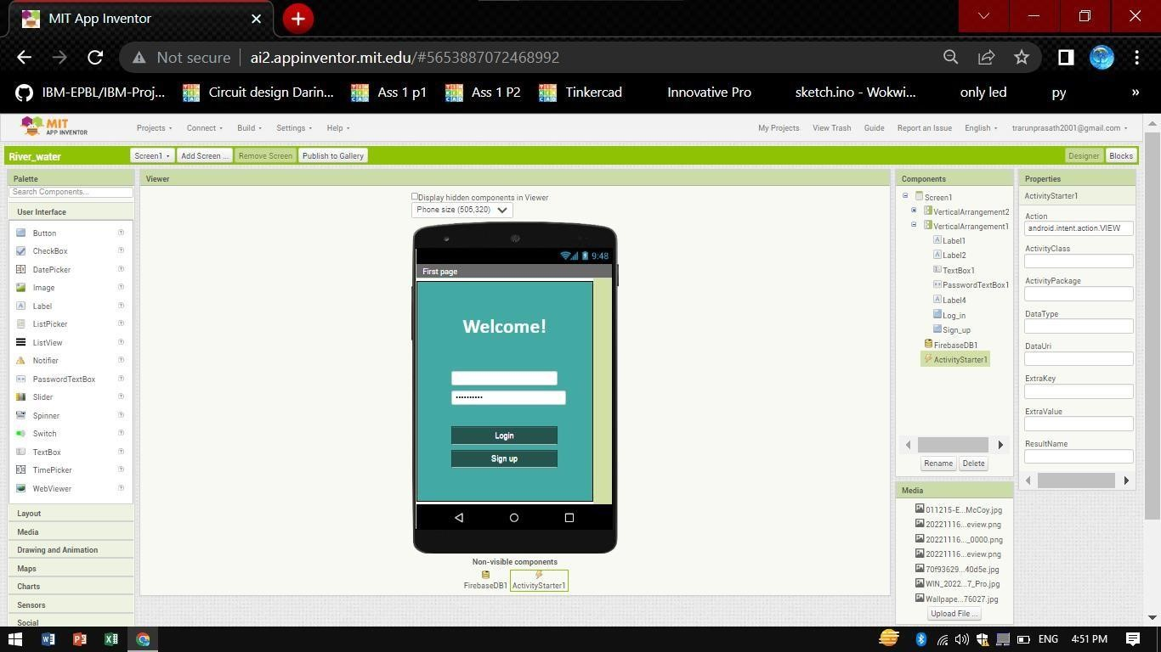

**SCREEN 1 Block Codes:**

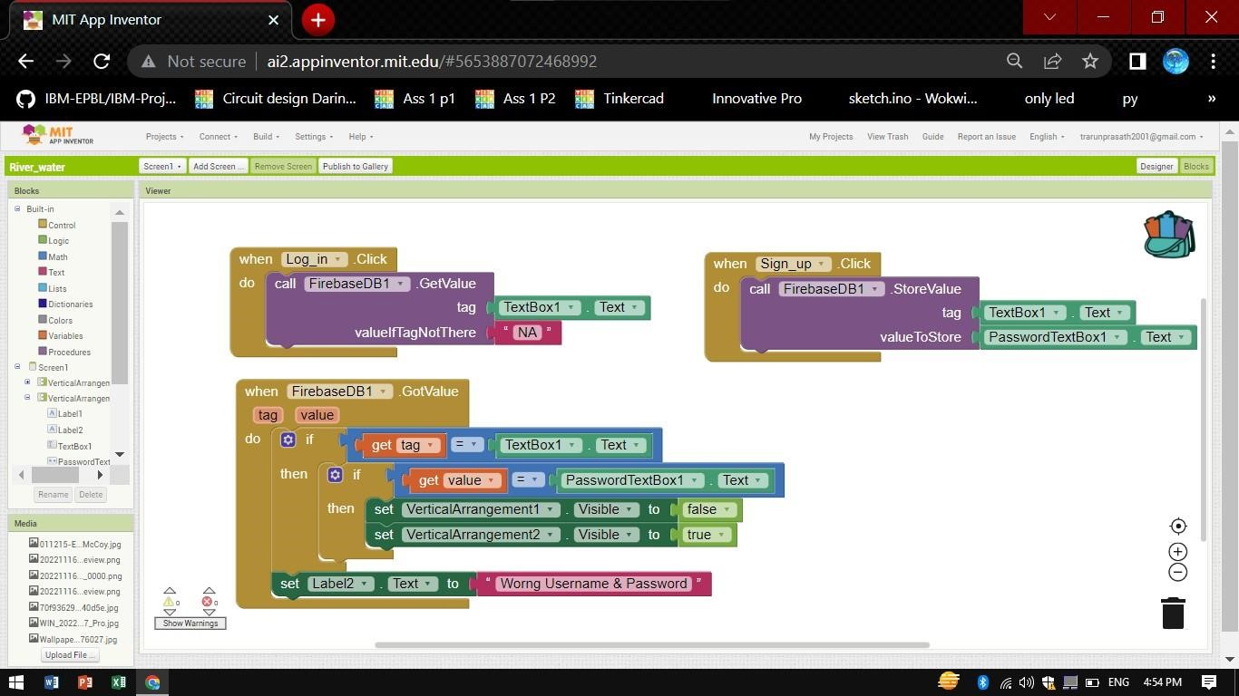

**SCREEN 2:**

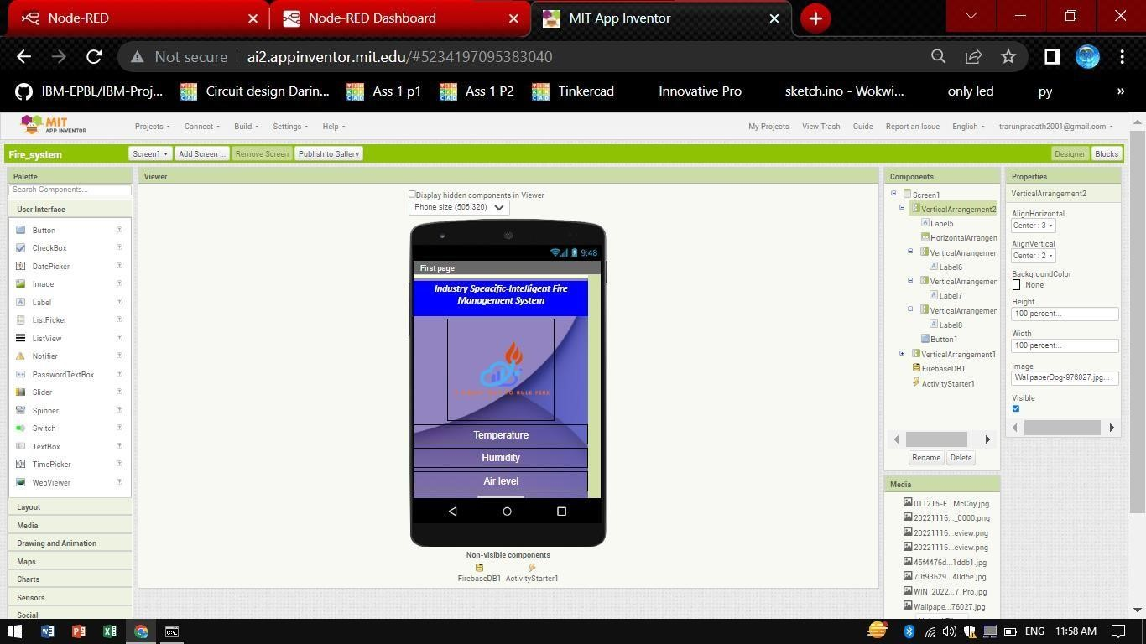

**SCREEN 2 Outputs:**

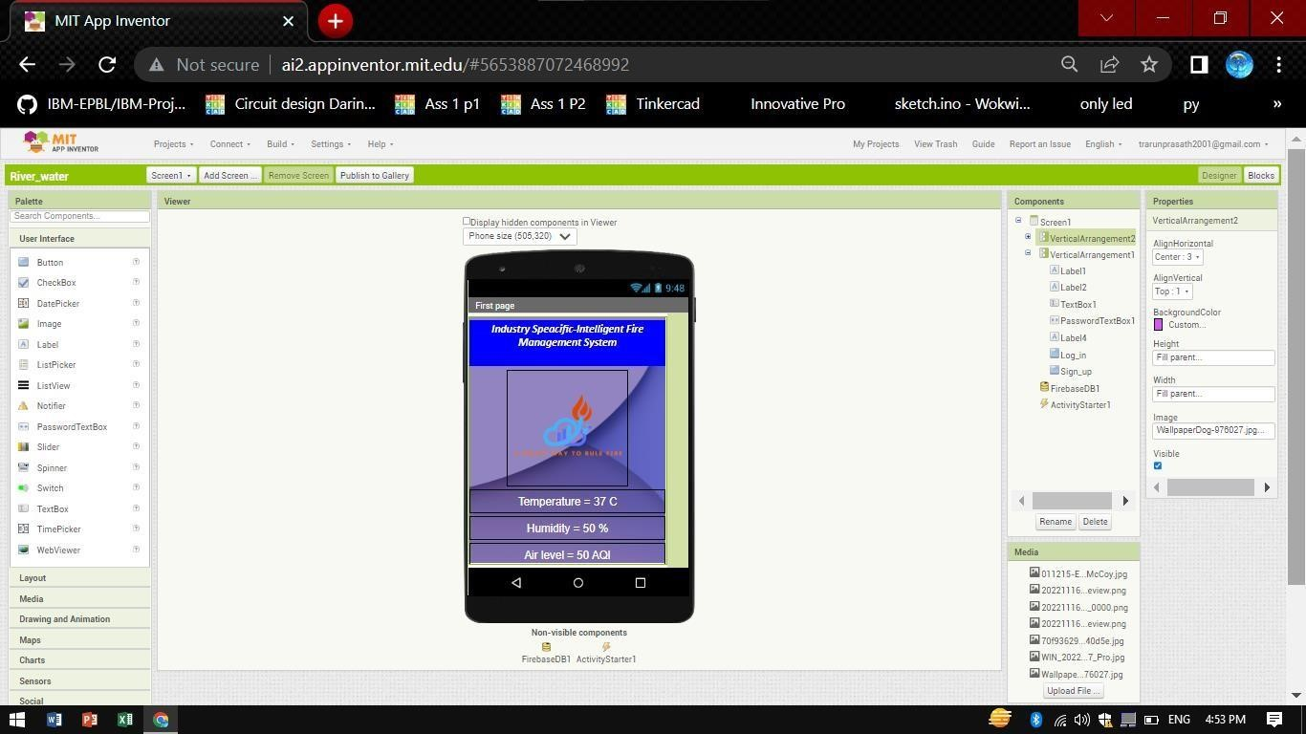

**SCREEN 2 Block Codes:**

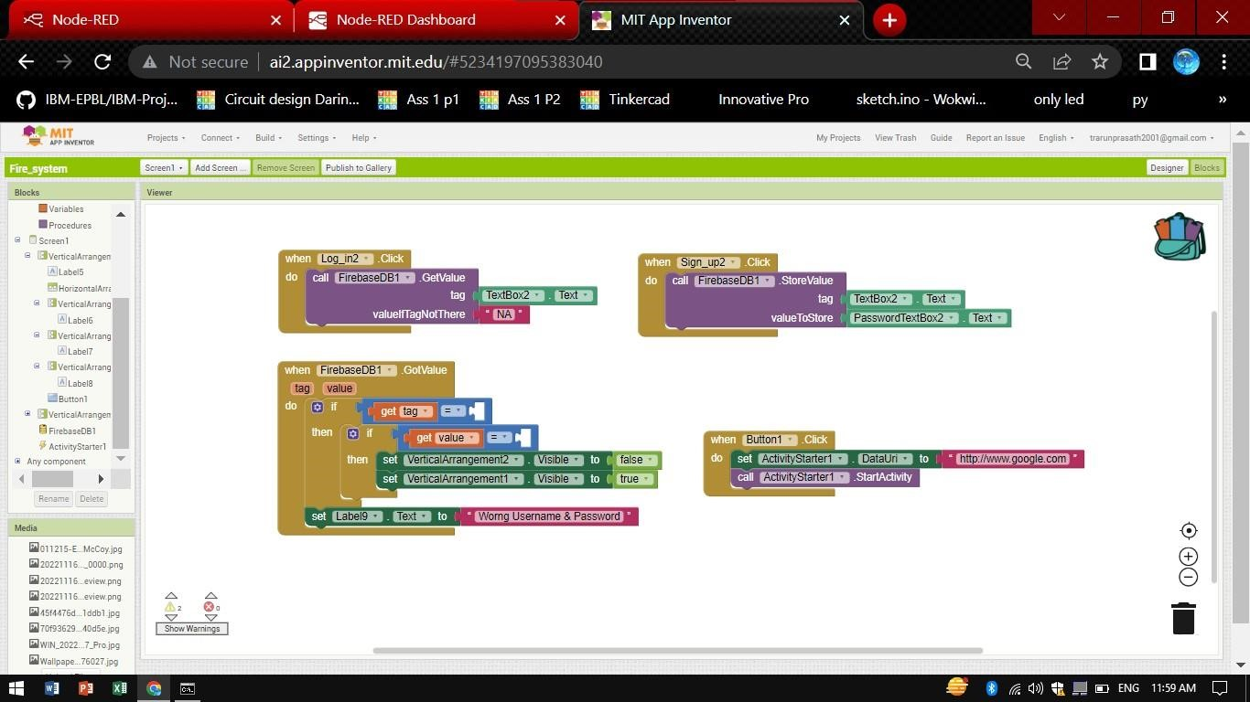

# Qr code for application

